Day – 1 Assignment

Install Wireshark on your laptop, start a capture on your main network interface, and visit any website (like instagram.com). Stop the capture and note down the protocol names you see in the packet list.
Ans :
Wireshark Practical
1. Install Wireshark
- Download and install Wireshark from the official website.
- During installation, allow Npcap to be installed if asked.
2. Start Wireshark
- Open Wireshark.
- You will see network interfaces such as:
  - Wi-Fi
  - Ethernet
  - Bluetooth
3. Select your main network interface
- If you are connected through Wi-Fi, select Wi-Fi.
- Double-click Wi-Fi to start packet capture.
4. Visit a website
- While Wireshark is capturing, open Chrome/Edge.
- Visit instagram.com or another website.
- Wait for the page to load completely.
5. Stop the capture
- Go back to Wireshark.
- Click the red Stop button .
- Protocols you may see
In the Protocol column, you may see protocols such as:
Protocol | Purpose
DNS | Converts website names into IP addresses
TCP | Reliable communication between devices
UDP | Fast connectionless communication
TLS | Encrypts secure web traffic
QUIC | Transport protocol commonly used with HTTP/3
HTTP | Web communication (if unencrypted)
ARP | Finds the MAC address for a local IP
ICMP | Used for network diagnostic messages

Pick any 3 packets from your Wireshark capture and identify which OSI layer each packet mainly represents (for example, HTTP for Application layer, TCP for Transport layer, etc.).<br><br><em><strong>Hint:</strong> Use the Protocol column and Info details in Wireshark to help you map protocols to OSI layers.</em>
Ans :
Packet Protocol | OSI Layer | Reason
DNS | Layer 7 – Application | DNS translates a website name like instagram.com into an IP address.
TCP | Layer 4 – Transport | TCP provides reliable communication between devices.
ARP | Layer 2 – Data Link | ARP helps find the MAC address associated with a local IP address.

Create a colorful diagram of the OSI Model using any drawing tool (MS Paint, Canva, or even paper and upload a photo). For each layer, add a real-world example from apps you use daily (e.g., WhatsApp uses the Application layer, Instagram images use the Presentation layer, etc.).
Ans :
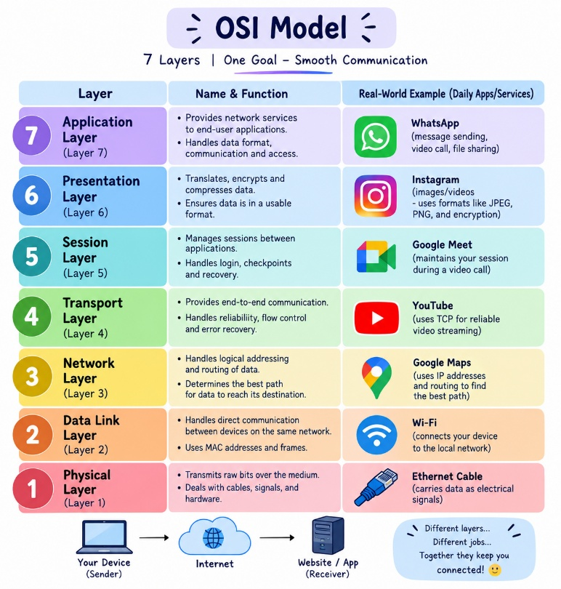

Explain how sending a message on WhatsApp travels through at least 4 layers of the OSI Model, describing what happens at each layer in your own words.<br><br><em><strong>Hint:</strong> Think about how your message is typed, packaged, sent over the internet, and received.</em>
Ans :
Example: Sending “Hello” on WhatsApp
- Application Layer – Layer 7
You type “Hello” in WhatsApp and press Send. WhatsApp prepares the message for communication.
- Presentation Layer – Layer 6
The message is formatted and encrypted so that it can be safely transmitted over the network.
- Transport Layer – Layer 4
The message is divided into smaller data segments and the transport protocol helps deliver them reliably to the destination.
- Network Layer – Layer 3
The message gets IP addressing and routing information. Routers use IP addresses to decide where the data should go.
- Data Link Layer – Layer 2
The data is put into frames and MAC addresses are used for communication on the local network, such as between your phone and Wi-Fi router.
- Physical Layer – Layer 1
Finally, the data is converted into electrical, radio, or optical signals and sent through Wi-Fi/mobile networks.

